
November 23 - 25, 2025

Schedule at a Glance
Sunday
11:00 AM – 7:15 PM Registration Desk is Open
1:00 PM – 7:15 PM – Sessions (6 hr., 3 hr., 1.5 hr., and 1.25 hr. sessions available)

Monday
7:00 AM – 4:30 PM Registration Desk is Open
7:00 AM – Coffee and Tea for early risers
8:00 AM – 9:30 AM – Sessions
– Yes I Can Activities and Reception (8 AM - 1 PM)
9:45 AM – 12:00 PM – General Session - Awards, 25-Year Recognitions, Keynote & More
12:00 PM – Grab and Go Lunch (sandwiches, salad, chips, and more) is available for credit card purchase until 1:15 PM (by escalators). Tables will be available in the Expo Area and in several session rooms. This is a good Team Time & networking opportunity!
1:15 PM – 4:30 PM – Sessions (1.5 hr. sessions and poster sessions)

Tuesday
7:30 AM – 11:30 AM – Registration Desk is Open
7:30 AM – Coffee and Tea for early risers
8:30 AM – 11:45 AM – Sessions (3 hr. sessions / Make and Take and Workshops)

Thank you to our partners!





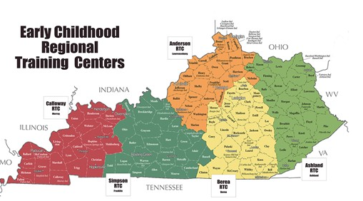










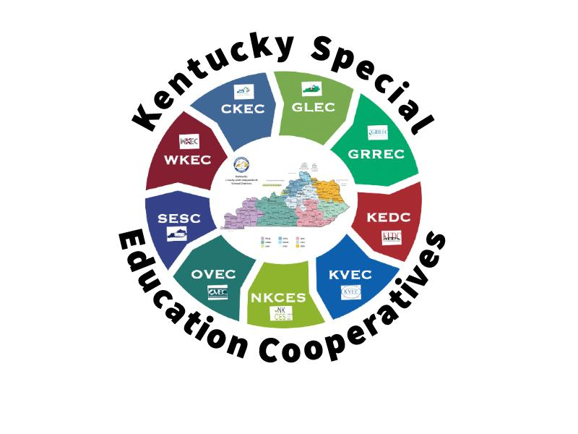

November 24, 20

